|  |
| --- |
| IFC-based Construction Industry Ontology and Semantic Web Services Framework |

**Le Zhang, Graduate Research Assistant,** [zhangle@ufl.edu](mailto:zhangle@ufl.edu)

Raja R. A. Issa, Rinker Professor, [raymond-issa@ufl.edu](mailto:raymond-issa@ufl.edu)

*Rinker School of Building Construction, University of Florida, Gainesville, FL, USA*

Hazar Dib, Assistant Professor, [hdib@purdue.edu](mailto:hdib@purdue.edu)

*Department of Building Construction Management, Purdue University, West Lafayette, IN*

# ABSTRACT

A construction project is a multi-disciplinary team effort combining inputs from various domains, for which interoperability is of great importance. Currently existing data exchange problems between different software applications is adversely impacting the overall productivity of the Architecture, Engineering and Construction (AEC) industry. The use of Industry Foundation Classes (IFC) has been proposed to help address the lack of interoperability throughout construction industry. But the IFC specification itself is too complicated for normal users without special training.

This paper proposes a semantic Web Services framework utilizing IFC-based industry ontology to address the interoperability problem. First, the possibility of building an IFC-based construction industry ontology is reviewed. Then, a framework to build semantic Web Services on this ontology is suggested. Both a core service and an assistant service is included. The framework is easily expanded as long as the same Web Services model and the common ontology is observed. Once implemented, the framework could be utilized by any IFC-supported BIM applications, as well as personnel without extensive knowledge of IFC specifications, for more precise, consistent and up-to-date project information retrieval, which is expected to further the effort of IFC and enhance and improve interoperability in the AEC industry without requiring extremely technologically savvy users.

**Keywords:** BIM, IFC, Web Services, semantic, ontology

# INTRODUCTION

A construction project is a multi-disciplinary team effort combining valuable and unique inputs of stakeholders from various domains, including owners, architects, engineers, contractors and facility managers. Among other requirements of interoperability, correct and timely information sharing between the parties is of vital value for a successful project, as well as the continuous development of the whole industry.

In this paper a Web Services approach is proposed to address these problems. After a brief review of Semantic Web and Web Services technologies, the possibility of building an IFC-based construction industry ontology structure is discussed. Then, an expandable semantic Web Services framework build on the IFC ontology is suggested. If this framework is implemented, all IFC-supported BIM applications could utilize the framework for precise, consistent and up-to-date construction industry and project information, which is expected to greatly enhance and improve the interoperability.

# SEMANTIC WEB SERVICES

## Semantic Web and ontologies

The World Wide Web is experiencing an upgrade from Web 2.0 to Web 3.0. The goal of this upgrade is to transform the Internet into a distributed computing platform that could utilize the scattered computing resources over the web to finish given tasks intelligently and automatically. This transformation to Cloud computing will also affect how traditional desk-top software works, including BIM and other construction industry applications.

The World Wide Web was initially designed as a document system whose content is meant to be displayed by Web browsers and is only meaningful to human readers rather than to computers (Cardoso 2007). The data and information expressed on a web page is difficult for a computer to extract and understand, thus preventing further automated information processing (Berners-Lee et al. 2001, Issa et al. 2012). As a result, from the point of view of a computer, the current Web is similar to a huge library without any indexing system. The information it needs is stored somewhere, but there is no way to find it. The Semantic Web project was initiated in the hope of giving order and meaning to the unstructured information available on the Web by adding contextual information (i.e. metadata) to existing information. As a result, computers will have the intellectual ability to discover, understand and process the data from diverse sources automatically without human interference.

Web Services encapsulate certain functions, which could be accessed by other applications over the Internet via appropriate interface. The advantage of Web Services is that it integrates different applications via a platform-independent standards-based framework (Cardoso 2007). The basic working model of Web Services consists of two roles: a service consumer and a service provider. A service consumer is an entity that needs the function in some Web Service. A service provider is an entity that could finish certain computing tasks and return the result to the consumer. The key is that the service provider is remotely located and communicates with the consumer through predefined interface via Internet protocols. The service provider may provide the service based on its local resources, but more importantly, it could search the web and provide the result on the fly. In the reality, as long as the consumer knows the URI of the provider, it can communicate with the provider directly. If not, a third party, the service registry, may be needed to match-make the consumers to the providers. Information available on the registry includes the services provided by the service providers as well as the parameters needed to finish the service. This model is shown in Figure 1.

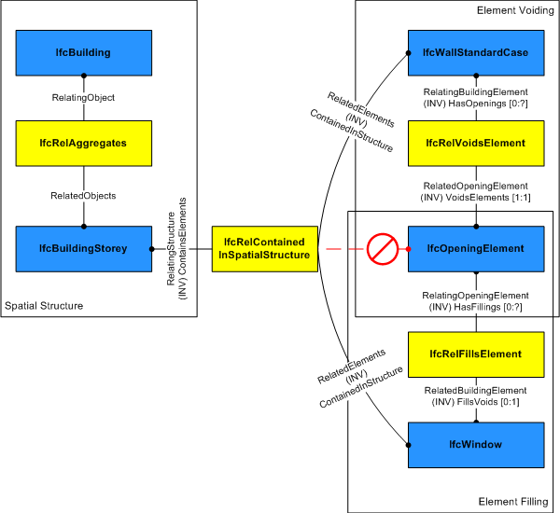

Figure 1: Relations in IFC specifications (IAI 2010)

# CONCLUSIONS AND FUTURE WORK

This paper address the interoperability problem in construction industry by proposing an IFC-based ontology and Semantic Web Services framework. Once implemented, the framework could be utilized by all IFC-supported BIM applications as well as personnel for more precise, consistent and up-to-date project information from all platforms supporting Web Services. It is expected this framework will benefit the operation staff on the construction site and greatly enhance the interoperability of construction industry software applications.

However, the experimental framework is far from complete. For example, the ontology used in the current framework is primitive with very limited entries. A complete industry-wide ontology requires much more work to build and constant maintenance to be actually useful. How to evaluate and integrate the currently available ontology is also an interesting topic. Although Web Services is expected to be adopted as main application distribution platform due to its advantage as a pay-per-use service model, its commercial application in the construction industry needs more research.

# ACKNOWLEDGMENTS

This paper sample contains a portion of an already published written by the conference organizers and has been altered to the extent needed to illustrate certain features.

# references

Berners-Lee, T., Hendler, J., and Lassila, O. (2001) "The Semantic Web." *Science American*, 284(5), 34.

Campbell, D. A. (2007). "Building Information Modeling: the Web3D application for AEC." *Proceedings of the twelfth international conference on 3D web technology*, ACM, New York, NY, USA, 173-176.

Cardoso, J. (2007). "Semantic Web Services: Theory, Tools and Applications." IGI Global.

IAI. "IfcWindow." <http://www.iai-tech.org/ifc/IFC2x4/beta3/html/ifcsharedbldgelements/lexical/ifcwindow.htm> (5/20/2010, 2010).